Module-9.R

r1916748

2023-03-13

# Load data  
data1 <- read.csv("BankWages.csv")  
  
  
# Visualization 1: simple Histogram  
hist(data1$education)  
  
# Visualization 2: simple Histogram  
library(lattice)

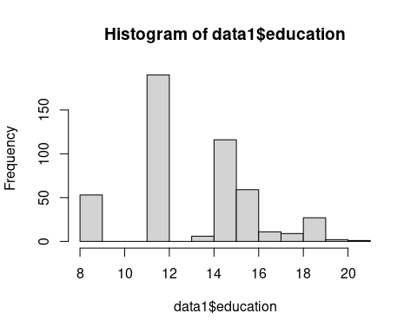

histogram(~education,data=data1,  
 type="density",  
 xlab="Number of years completed",  
 main="Education levels among employees")

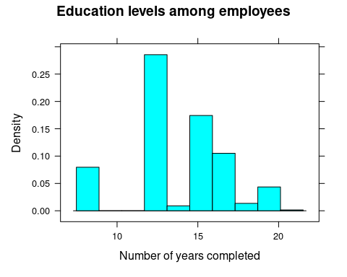

# Visualization 3: simple Histogram  
install.packages("ggplot2")

## Installing package into '/cloud/lib/x86_64-pc-linux-gnu-library/4.2'  
## (as 'lib' is unspecified)

library(ggplot2)  
h<-ggplot(data1, aes(x=education)) +   
 geom_histogram(color="yellow", fill="green", binwidth = 1)  
h

